Thread 0425920f
Source: https://my.remarkbox.com/0425920f-c6cb-11ef-9715-29ab4fb285a0
Snapshot: 2026-05-03T10:48:38Z
Generator: Remarkbox 763cacb
This is a subthread snapshot. The living document lives at the source URI above — it may have been edited, extended, or replied-to since.
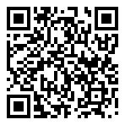
Scan for living source
I have been unable to use my phone since Friday. I am with Hello Mobile , apparently a Q link company. Nothing is working with the sites. I need help, NOW!!

Source: https://my.remarkbox.com/0425920f-c6cb-11ef-9715-29ab4fb285a0
Snapshot: 2026-05-03T10:48:38Z
Generator: Remarkbox 763cacb

