Thread 0621545b
Source: https://my.remarkbox.com/0621545b-e63d-11eb-bced-040140774501
Snapshot: 2026-05-03T09:26:29Z
Generator: Remarkbox 763cacb
This is a subthread snapshot. The living document lives at the source URI above — it may have been edited, extended, or replied-to since.
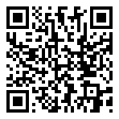
Scan for living source
Same for me since 7-13-2021. No internet/mobile data and I'm SUPPOSED to have UNLIMITED DATA.

Source: https://my.remarkbox.com/0621545b-e63d-11eb-bced-040140774501
Snapshot: 2026-05-03T09:26:29Z
Generator: Remarkbox 763cacb

