Thread 0783d13d
Source: https://my.remarkbox.com/0783d13d-a064-11ef-a4e7-29ab4fb285a0
Snapshot: 2026-05-03T09:25:46Z
Generator: Remarkbox 763cacb
This is a subthread snapshot. The living document lives at the source URI above — it may have been edited, extended, or replied-to since.
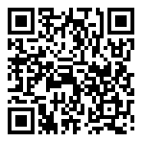
Scan for living source
My network service not working. I'm in Shreveport Louisiana

Source: https://my.remarkbox.com/0783d13d-a064-11ef-a4e7-29ab4fb285a0
Snapshot: 2026-05-03T09:25:46Z
Generator: Remarkbox 763cacb

