Thread 080fb8ed
Source: https://my.remarkbox.com/080fb8ed-521b-11ed-bc4e-83aad5f5c937
Snapshot: 2026-05-03T09:25:47Z
Generator: Remarkbox 763cacb
This is a subthread snapshot. The living document lives at the source URI above — it may have been edited, extended, or replied-to since.
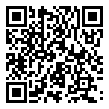
Scan for living source
My uncle has no calling, In or out. Only text and data. Where I having the same service have no issues. Check on Tamaqua Pa please.

Source: https://my.remarkbox.com/080fb8ed-521b-11ed-bc4e-83aad5f5c937
Snapshot: 2026-05-03T09:25:47Z
Generator: Remarkbox 763cacb

