Thread 0913f0b1
Source: https://my.remarkbox.com/0913f0b1-ddc4-11ee-a2db-751976fc35b2
Snapshot: 2026-05-03T09:26:37Z
Generator: Remarkbox 763cacb
This is a subthread snapshot. The living document lives at the source URI above — it may have been edited, extended, or replied-to since.
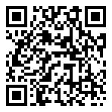
Scan for living source
I have had on and off service for 3 days now. Right now no phone or internet services. I’m in 85553 service area

Source: https://my.remarkbox.com/0913f0b1-ddc4-11ee-a2db-751976fc35b2
Snapshot: 2026-05-03T09:26:37Z
Generator: Remarkbox 763cacb

