Thread 09562961
Source: https://my.remarkbox.com/09562961-6f90-11ed-84c1-83aad5f5c937
Snapshot: 2026-05-03T10:50:01Z
Generator: Remarkbox 763cacb
This is a subthread snapshot. The living document lives at the source URI above — it may have been edited, extended, or replied-to since.
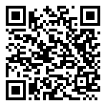
Scan for living source
I have shitty service when I turn on my cellular… it’s been like that for years

Source: https://my.remarkbox.com/09562961-6f90-11ed-84c1-83aad5f5c937
Snapshot: 2026-05-03T10:50:01Z
Generator: Remarkbox 763cacb

