Thread 0c362c61
Source: https://my.remarkbox.com/0c362c61-289c-11ed-af60-83aad5f5c937
Snapshot: 2026-05-03T09:31:17Z
Generator: Remarkbox 763cacb
This is a subthread snapshot. The living document lives at the source URI above — it may have been edited, extended, or replied-to since.
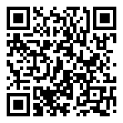
Scan for living source
Newport, Oregon. Cannot access data for over a week now, called support and they said tower outage. It's been 4 days since then.

Source: https://my.remarkbox.com/0c362c61-289c-11ed-af60-83aad5f5c937
Snapshot: 2026-05-03T09:31:17Z
Generator: Remarkbox 763cacb

