Thread 0deebb52
Source: https://my.remarkbox.com/0deebb52-c935-11eb-a858-040140774501
Snapshot: 2026-05-03T10:47:35Z
Generator: Remarkbox 763cacb
This is a subthread snapshot. The living document lives at the source URI above — it may have been edited, extended, or replied-to since.
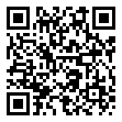
Scan for living source
I can make phone calls on q link phone locally anyway but cannot get into websiste or get text status from them.

Source: https://my.remarkbox.com/0deebb52-c935-11eb-a858-040140774501
Snapshot: 2026-05-03T10:47:35Z
Generator: Remarkbox 763cacb

