Thread 121c2b77
Source: https://my.remarkbox.com/121c2b77-c8b0-11ec-a5a9-b1c8c4ae987e
Snapshot: 2026-05-01T19:03:37Z
Generator: Remarkbox 763cacb
This is a subthread snapshot. The living document lives at the source URI above — it may have been edited, extended, or replied-to since.
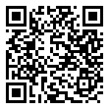
Scan for living source
Surfshark is out on my laptop, but not my cell.
App shows as current, with no updates available.
Buffalo, N.Y.

Source: https://my.remarkbox.com/121c2b77-c8b0-11ec-a5a9-b1c8c4ae987e
Snapshot: 2026-05-01T19:03:37Z
Generator: Remarkbox 763cacb

