Thread 18f8ee89
Source: https://my.remarkbox.com/18f8ee89-349b-11ec-9a98-040140774501
Snapshot: 2026-05-03T12:02:59Z
Generator: Remarkbox 763cacb
This is a subthread snapshot. The living document lives at the source URI above — it may have been edited, extended, or replied-to since.
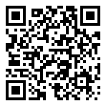
Scan for living source
No service in Markham, WA 98520 since about 08/01/2021. Had service 10/01/2019 - 07/31/2021. It's been down ever since.

Source: https://my.remarkbox.com/18f8ee89-349b-11ec-9a98-040140774501
Snapshot: 2026-05-03T12:02:59Z
Generator: Remarkbox 763cacb

