Thread 1da9b401
Source: https://my.remarkbox.com/1da9b401-c888-11eb-a843-040140774501
Snapshot: 2026-05-03T10:48:42Z
Generator: Remarkbox 763cacb
This is a subthread snapshot. The living document lives at the source URI above — it may have been edited, extended, or replied-to since.
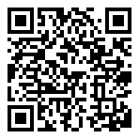
Scan for living source
Qlink wireless service not working for me in WA DC. This sucks...been a week almost.

Source: https://my.remarkbox.com/1da9b401-c888-11eb-a843-040140774501
Snapshot: 2026-05-03T10:48:42Z
Generator: Remarkbox 763cacb

