Thread 2cf20789
Source: https://my.remarkbox.com/2cf20789-03f8-11ef-afc5-1f90b6841245
Snapshot: 2026-05-03T10:47:39Z
Generator: Remarkbox 763cacb
This is a subthread snapshot. The living document lives at the source URI above — it may have been edited, extended, or replied-to since.
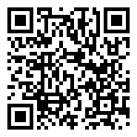
Scan for living source
Since yesterday, 4/25/2024 I keep getting this msg: server unreachable. Are the Qlink servers down?

Source: https://my.remarkbox.com/2cf20789-03f8-11ef-afc5-1f90b6841245
Snapshot: 2026-05-03T10:47:39Z
Generator: Remarkbox 763cacb

