Thread 335833f6
Source: https://my.remarkbox.com/335833f6-4208-11e9-9d31-040140774501
Snapshot: 2026-04-27T19:05:22Z
Generator: Remarkbox 763cacb
This is a subthread snapshot. The living document lives at the source URI above — it may have been edited, extended, or replied-to since.
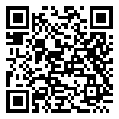
Scan for living source
nifty; I was looking for the bundle ID for Textmate (preview) and for R.app... the mdls part of this post solved it for me, and you're the #1 google link for r bundle id :-)
The 1-liner solution is
mdls -name kMDItemCFBundleIdentifier -r /Applications/R.app

Source: https://my.remarkbox.com/335833f6-4208-11e9-9d31-040140774501
Snapshot: 2026-04-27T19:05:22Z
Generator: Remarkbox 763cacb

