Thread 35ba9723
Source: https://my.remarkbox.com/35ba9723-4208-11e9-9d31-040140774501
Snapshot: 2026-05-06T09:43:05Z
Generator: Remarkbox 763cacb
This is a subthread snapshot. The living document lives at the source URI above — it may have been edited, extended, or replied-to since.
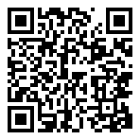
Scan for living source
Didn’t work for me:
➤ sqlite3 ~/Library/Mail/V2/MailData/Envelope\ Index vacuum;
SQL error: file is encrypted or is not a database

Source: https://my.remarkbox.com/35ba9723-4208-11e9-9d31-040140774501
Snapshot: 2026-05-06T09:43:05Z
Generator: Remarkbox 763cacb

