Thread 381cbc91
Source: https://my.remarkbox.com/381cbc91-4208-11e9-9d31-040140774501
Snapshot: 2026-04-28T16:59:49Z
Generator: Remarkbox 763cacb
This is a subthread snapshot. The living document lives at the source URI above — it may have been edited, extended, or replied-to since.
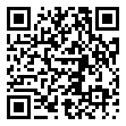
Scan for living source
Purchased on the basis of your post. This is going to come in very handy, thanks.
The repeated misspelling of "Perl" as "Pearl" is amusing, though (in the supported languages list on the product page; in the app's export dropdown)

Source: https://my.remarkbox.com/381cbc91-4208-11e9-9d31-040140774501
Snapshot: 2026-04-28T16:59:49Z
Generator: Remarkbox 763cacb

