Thread 386cc29f
Source: https://my.remarkbox.com/386cc29f-f922-11eb-a891-040140774501
Snapshot: 2026-05-07T14:58:48Z
Generator: Remarkbox 763cacb
This is a subthread snapshot. The living document lives at the source URI above — it may have been edited, extended, or replied-to since.
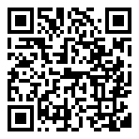
Scan for living source
Whilst internet is OK, no phone connection all day in IP11 area. When is it coming back online?

Source: https://my.remarkbox.com/386cc29f-f922-11eb-a891-040140774501
Snapshot: 2026-05-07T14:58:48Z
Generator: Remarkbox 763cacb

