Thread 3b618943
Source: https://my.remarkbox.com/3b618943-ce44-11ec-a5c0-b1c8c4ae987e
Snapshot: 2026-05-03T10:48:39Z
Generator: Remarkbox 763cacb
This is a subthread snapshot. The living document lives at the source URI above — it may have been edited, extended, or replied-to since.
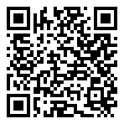
Scan for living source
May 7, 2022 No mobile service. Can't make phone calls. Cascade, Colorado

Source: https://my.remarkbox.com/3b618943-ce44-11ec-a5c0-b1c8c4ae987e
Snapshot: 2026-05-03T10:48:39Z
Generator: Remarkbox 763cacb

