Thread 3ecbe01b
Source: https://my.remarkbox.com/3ecbe01b-9b9a-11eb-9934-040140774501
Snapshot: 2026-05-07T14:56:51Z
Generator: Remarkbox 763cacb
This is a subthread snapshot. The living document lives at the source URI above — it may have been edited, extended, or replied-to since.
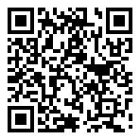
Scan for living source
We are having an issue with our telephone line and are unable to make or receive calls. Salisbury.

Source: https://my.remarkbox.com/3ecbe01b-9b9a-11eb-9934-040140774501
Snapshot: 2026-05-07T14:56:51Z
Generator: Remarkbox 763cacb

