Thread 45249951
Source: https://my.remarkbox.com/45249951-d648-11eb-ab4a-040140774501
Snapshot: 2026-05-03T10:48:59Z
Generator: Remarkbox 763cacb
This is a subthread snapshot. The living document lives at the source URI above — it may have been edited, extended, or replied-to since.
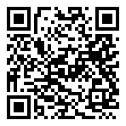
Scan for living source
My phone stopped being able to use the internet. I have h limited talk text and data but it says I'm out of data. Started a little over a week ago

brwzQzql — Jul 16, 2021 09:52 am
Same for me since 7-13-2021. No internet/mobile data and I'm SUPPOSED to have UNLIMITED DATA.

Source: https://my.remarkbox.com/45249951-d648-11eb-ab4a-040140774501
Snapshot: 2026-05-03T10:48:59Z
Generator: Remarkbox 763cacb

