Thread 4c5cfcff
Source: https://my.remarkbox.com/4c5cfcff-c931-11eb-a857-040140774501
Snapshot: 2026-05-03T11:55:44Z
Generator: Remarkbox 763cacb
This is a subthread snapshot. The living document lives at the source URI above — it may have been edited, extended, or replied-to since.
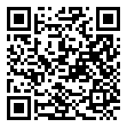
Scan for living source
Q link wireless service down in Houston TX I believe. Busy signal if call and cannot access internet site.

Source: https://my.remarkbox.com/4c5cfcff-c931-11eb-a857-040140774501
Snapshot: 2026-05-03T11:55:44Z
Generator: Remarkbox 763cacb

