Thread 4d56e301
Source: https://my.remarkbox.com/4d56e301-a0c5-11ed-985b-83aad5f5c937
Snapshot: 2026-04-27T22:33:00Z
Generator: Remarkbox 763cacb
This is a subthread snapshot. The living document lives at the source URI above — it may have been edited, extended, or replied-to since.
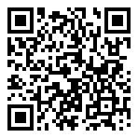
Scan for living source
cell phone #217-685-2132 Chatham, IL No service as of now. What's happening?

Source: https://my.remarkbox.com/4d56e301-a0c5-11ed-985b-83aad5f5c937
Snapshot: 2026-04-27T22:33:00Z
Generator: Remarkbox 763cacb

