Thread 50bf2cb4
Source: https://my.remarkbox.com/50bf2cb4-d9c7-11eb-adb1-040140774501
Snapshot: 2026-05-03T10:47:25Z
Generator: Remarkbox 763cacb
This is a subthread snapshot. The living document lives at the source URI above — it may have been edited, extended, or replied-to since.
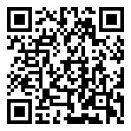
Scan for living source
Service down since Saturday! I noticed T-Mobile is also down in my area. How long before the problem is fixed?

Source: https://my.remarkbox.com/50bf2cb4-d9c7-11eb-adb1-040140774501
Snapshot: 2026-05-03T10:47:25Z
Generator: Remarkbox 763cacb

