Thread 5226158b
Source: https://my.remarkbox.com/5226158b-a147-11eb-9f82-040140774501
Snapshot: 2026-05-09T16:51:28Z
Generator: Remarkbox 763cacb
This is a subthread snapshot. The living document lives at the source URI above — it may have been edited, extended, or replied-to since.
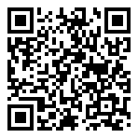
Scan for living source
Both Zoomer landline and cell continue to be out. Except for email am totally without the ability to communicate.

Source: https://my.remarkbox.com/5226158b-a147-11eb-9f82-040140774501
Snapshot: 2026-05-09T16:51:28Z
Generator: Remarkbox 763cacb

