Thread 52d117a5
Source: https://my.remarkbox.com/52d117a5-5e58-11ef-b26c-1f90b6841245
Snapshot: 2026-05-03T09:27:14Z
Generator: Remarkbox 763cacb
This is a subthread snapshot. The living document lives at the source URI above — it may have been edited, extended, or replied-to since.
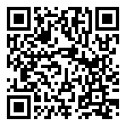
Scan for living source
Q link wireless service not working. Checked my account and a message popped up about not having service in this area. Then I restart my phone and a message popped up about my sim card not being provisioned

Source: https://my.remarkbox.com/52d117a5-5e58-11ef-b26c-1f90b6841245
Snapshot: 2026-05-03T09:27:14Z
Generator: Remarkbox 763cacb

