Thread 537285bf
Source: https://my.remarkbox.com/537285bf-0c53-11ec-815f-040140774501
Snapshot: 2026-05-03T11:53:18Z
Generator: Remarkbox 763cacb
This is a subthread snapshot. The living document lives at the source URI above — it may have been edited, extended, or replied-to since.
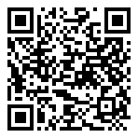
Scan for living source
Is Qlinkwirless LTE/internet service down for Akron, Ohio?

iGtaQH3l — Mar 27, 2022 11:49 pm
I am in Ohio..my service out since about noon 3/27/2022

Source: https://my.remarkbox.com/537285bf-0c53-11ec-815f-040140774501
Snapshot: 2026-05-03T11:53:18Z
Generator: Remarkbox 763cacb

