Thread 53888b08
Source: https://my.remarkbox.com/53888b08-4208-11e9-9d31-040140774501
Snapshot: 2026-05-03T11:02:07Z
Generator: Remarkbox 763cacb
This is a subthread snapshot. The living document lives at the source URI above — it may have been edited, extended, or replied-to since.
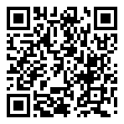
Scan for living source
Nice list, thank you. Could you please explain what made you switch to Pocket instead of your previous preferred app?

Source: https://my.remarkbox.com/53888b08-4208-11e9-9d31-040140774501
Snapshot: 2026-05-03T11:02:07Z
Generator: Remarkbox 763cacb

