Thread 55ed5e04
Source: https://my.remarkbox.com/55ed5e04-4208-11e9-9d31-040140774501
Snapshot: 2026-05-07T02:57:31Z
Generator: Remarkbox 763cacb
This is a subthread snapshot. The living document lives at the source URI above — it may have been edited, extended, or replied-to since.
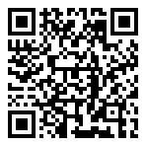
Scan for living source
I ran the feed through FeedBurner to convert it to RSS2 and it now works fine.

Source: https://my.remarkbox.com/55ed5e04-4208-11e9-9d31-040140774501
Snapshot: 2026-05-07T02:57:31Z
Generator: Remarkbox 763cacb

