Thread 57c0a5bd
Source: https://my.remarkbox.com/57c0a5bd-ce4b-11ec-a5c0-b1c8c4ae987e
Snapshot: 2026-05-03T09:28:50Z
Generator: Remarkbox 763cacb
This is a subthread snapshot. The living document lives at the source URI above — it may have been edited, extended, or replied-to since.
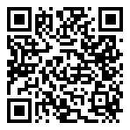
Scan for living source
Is qlink having service outage in Kentucky my phone hasn’t had service all day

Source: https://my.remarkbox.com/57c0a5bd-ce4b-11ec-a5c0-b1c8c4ae987e
Snapshot: 2026-05-03T09:28:50Z
Generator: Remarkbox 763cacb

