Thread 59fcff6f
Source: https://my.remarkbox.com/59fcff6f-3950-11ec-9d90-040140774501
Snapshot: 2026-05-03T10:47:44Z
Generator: Remarkbox 763cacb
This is a subthread snapshot. The living document lives at the source URI above — it may have been edited, extended, or replied-to since.
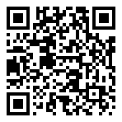
Scan for living source
Is qlink down now? Can make calls but no internet. Charleston wv

Source: https://my.remarkbox.com/59fcff6f-3950-11ec-9d90-040140774501
Snapshot: 2026-05-03T10:47:44Z
Generator: Remarkbox 763cacb

