Thread 5a0aa64d
Source: https://my.remarkbox.com/5a0aa64d-b881-11ef-ae21-29ab4fb285a0
Snapshot: 2026-05-03T10:47:33Z
Generator: Remarkbox 763cacb
This is a subthread snapshot. The living document lives at the source URI above — it may have been edited, extended, or replied-to since.
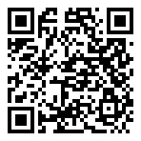
Scan for living source
what is going on with qlink wireless??? :My phone is not working and I cannot even get to the website???

Source: https://my.remarkbox.com/5a0aa64d-b881-11ef-ae21-29ab4fb285a0
Snapshot: 2026-05-03T10:47:33Z
Generator: Remarkbox 763cacb

