Thread 619e431a
Source: https://my.remarkbox.com/619e431a-52df-11ec-aef1-21646204cc72
Snapshot: 2026-05-03T11:52:49Z
Generator: Remarkbox 763cacb
This is a subthread snapshot. The living document lives at the source URI above — it may have been edited, extended, or replied-to since.
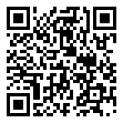
Scan for living source
I have been unable to make outgoing calls with my Qlink service since 4:50pm Monday,November29th. Qlink's help center keeps telling me to call Qlink's customer service line, but I can't make outgoing calls!! It's been almost 48 hours and Qlink refuses to respond.

Source: https://my.remarkbox.com/619e431a-52df-11ec-aef1-21646204cc72
Snapshot: 2026-05-03T11:52:49Z
Generator: Remarkbox 763cacb

