Thread 6b5feba3
Source: https://my.remarkbox.com/6b5feba3-4208-11e9-9d31-040140774501
Snapshot: 2026-04-27T08:21:59Z
Generator: Remarkbox 97a1fff
This is a subthread snapshot. The living document lives at the source URI above — it may have been edited, extended, or replied-to since.
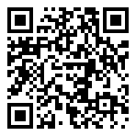
Scan for living source
Spillo is the key factor for me with Read Later stuff. There are iOS apps that can serve the purpose as well. Spillo can present my saved articles in an RSS reader type layout, and makes it easy to mark read/unread with keyboard shortcuts.

Source: https://my.remarkbox.com/6b5feba3-4208-11e9-9d31-040140774501
Snapshot: 2026-04-27T08:21:59Z
Generator: Remarkbox 97a1fff

