Thread 6cd21117
Source: https://my.remarkbox.com/6cd21117-71ff-11ef-b577-1f90b6841245
Snapshot: 2026-05-03T09:25:45Z
Generator: Remarkbox 763cacb
This is a subthread snapshot. The living document lives at the source URI above — it may have been edited, extended, or replied-to since.
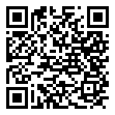
Scan for living source
I’m in Fairfield, CT and have been unable to make or receive any calls for days. I’ve sent messages to QLink thru their own system and have received no response. Any help with this issue would be greatly appreciated!

Source: https://my.remarkbox.com/6cd21117-71ff-11ef-b577-1f90b6841245
Snapshot: 2026-05-03T09:25:45Z
Generator: Remarkbox 763cacb

