Thread 6eb42ce5
Source: https://my.remarkbox.com/6eb42ce5-0998-11ec-bedc-040140774501
Snapshot: 2026-05-03T12:00:51Z
Generator: Remarkbox 763cacb
This is a subthread snapshot. The living document lives at the source URI above — it may have been edited, extended, or replied-to since.
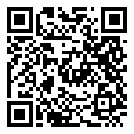
Scan for living source
Qlink is down in the Philadelphia area. No bars, telling me to sign into network. Bars have an X with no service.

Source: https://my.remarkbox.com/6eb42ce5-0998-11ec-bedc-040140774501
Snapshot: 2026-05-03T12:00:51Z
Generator: Remarkbox 763cacb

