Thread 71f9da07
Source: https://my.remarkbox.com/71f9da07-c99d-11eb-a867-040140774501
Snapshot: 2026-05-03T10:47:22Z
Generator: Remarkbox 763cacb
This is a subthread snapshot. The living document lives at the source URI above — it may have been edited, extended, or replied-to since.
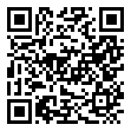
Scan for living source
Have to order a replacement phone but haven't been able to access qlinkwireless.com or their customer service number for more than 7 hours. Really frustrating.

Source: https://my.remarkbox.com/71f9da07-c99d-11eb-a867-040140774501
Snapshot: 2026-05-03T10:47:22Z
Generator: Remarkbox 763cacb

