Thread 72c72567
Source: https://my.remarkbox.com/72c72567-e45d-11ec-b8ef-83aad5f5c937
Snapshot: 2026-05-03T10:46:48Z
Generator: Remarkbox 763cacb
This is a subthread snapshot. The living document lives at the source URI above — it may have been edited, extended, or replied-to since.
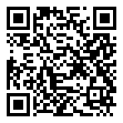
Scan for living source
Columbus Ohio zip code around 43228 and 43026 .. QLink cell towers out for 2 days now since June 03, 2022 still not back on!! no access to data .. can't call or receive calls .. horrible

Source: https://my.remarkbox.com/72c72567-e45d-11ec-b8ef-83aad5f5c937
Snapshot: 2026-05-03T10:46:48Z
Generator: Remarkbox 763cacb

