Thread 7711823a
Source: https://my.remarkbox.com/7711823a-8bd1-11ed-91e0-83aad5f5c937
Snapshot: 2026-04-27T22:34:12Z
Generator: Remarkbox 763cacb
This is a subthread snapshot. The living document lives at the source URI above — it may have been edited, extended, or replied-to since.
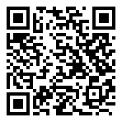
Scan for living source
Great Call representative informed me that their entire network of 3G flip phones is down. They are currently working to convert their service to 4G. We shouldn't expect service to be restored until Wednesday morning.

Source: https://my.remarkbox.com/7711823a-8bd1-11ed-91e0-83aad5f5c937
Snapshot: 2026-04-27T22:34:12Z
Generator: Remarkbox 763cacb

