Thread 7a32480f
Source: https://my.remarkbox.com/7a32480f-b642-11ee-9780-751976fc35b2
Snapshot: 2026-05-03T09:26:53Z
Generator: Remarkbox 763cacb
This is a subthread snapshot. The living document lives at the source URI above — it may have been edited, extended, or replied-to since.
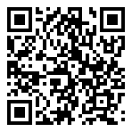
Scan for living source
My qlink service in St. Louis, MO says it's working but countless restarts, apps and searches tell me otherwise. That and the exclamation point next to my 5G status. Wish I could get some straight answers.

Source: https://my.remarkbox.com/7a32480f-b642-11ee-9780-751976fc35b2
Snapshot: 2026-05-03T09:26:53Z
Generator: Remarkbox 763cacb

