Thread 7cae1cbf
Source: https://my.remarkbox.com/7cae1cbf-9e4b-11eb-9e55-040140774501
Snapshot: 2026-05-03T10:46:56Z
Generator: Remarkbox 763cacb
This is a subthread snapshot. The living document lives at the source URI above — it may have been edited, extended, or replied-to since.
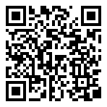
Scan for living source
For several weeks, Only Some calls and Some texts go through to my phone and my phone has No indication that a call was made. I do get some Voice Messages but without any notice to phone a call was made.

Source: https://my.remarkbox.com/7cae1cbf-9e4b-11eb-9e55-040140774501
Snapshot: 2026-05-03T10:46:56Z
Generator: Remarkbox 763cacb

