Thread 80b32339
Source: https://my.remarkbox.com/80b32339-47ea-11ec-aedf-21646204cc72
Snapshot: 2026-05-03T10:46:19Z
Generator: Remarkbox 763cacb
This is a subthread snapshot. The living document lives at the source URI above — it may have been edited, extended, or replied-to since.
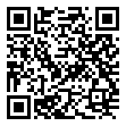
Scan for living source
Is Issa Asad a scammer? The service is junk. the excuses are junk. My phone worked fine until I put their sim card in. And they say the same thing every time I call try try and get this working again.

Source: https://my.remarkbox.com/80b32339-47ea-11ec-aedf-21646204cc72
Snapshot: 2026-05-03T10:46:19Z
Generator: Remarkbox 763cacb

