Thread 8295f723
Source: https://my.remarkbox.com/8295f723-c63d-11eb-a7bc-040140774501
Snapshot: 2026-04-27T22:32:29Z
Generator: Remarkbox 763cacb
This is a subthread snapshot. The living document lives at the source URI above — it may have been edited, extended, or replied-to since.
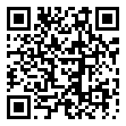
Scan for living source
Tried calling my mother's phone located in Clare, Michigan. She answers it but can't hear me. Is the system down in Northern Michigan?

Source: https://my.remarkbox.com/8295f723-c63d-11eb-a7bc-040140774501
Snapshot: 2026-04-27T22:32:29Z
Generator: Remarkbox 763cacb

