Thread 82a77db8
Source: https://my.remarkbox.com/82a77db8-8833-11ec-afac-21646204cc72
Snapshot: 2026-05-07T19:43:19Z
Generator: Remarkbox 763cacb
This is a subthread snapshot. The living document lives at the source URI above — it may have been edited, extended, or replied-to since.
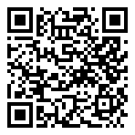
Scan for living source
My email has been down since mid aftenoon yesterday. I am in Durango Colorado

Source: https://my.remarkbox.com/82a77db8-8833-11ec-afac-21646204cc72
Snapshot: 2026-05-07T19:43:19Z
Generator: Remarkbox 763cacb

