Thread 859c8201
Source: https://my.remarkbox.com/859c8201-3141-11ec-9878-040140774501
Snapshot: 2026-05-03T10:49:56Z
Generator: Remarkbox 763cacb
This is a subthread snapshot. The living document lives at the source URI above — it may have been edited, extended, or replied-to since.
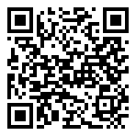
Scan for living source
I have literally jumped through hoops trying to get my service up and running through Qlink to no avail. Please is the network up and available at all? I'm located in Louisville, KY 40219

Source: https://my.remarkbox.com/859c8201-3141-11ec-9878-040140774501
Snapshot: 2026-05-03T10:49:56Z
Generator: Remarkbox 763cacb

