Thread 8c6b8f75
Source: https://my.remarkbox.com/8c6b8f75-8f78-11eb-9744-040140774501
Snapshot: 2026-05-03T12:07:37Z
Generator: Remarkbox 763cacb
This is a subthread snapshot. The living document lives at the source URI above — it may have been edited, extended, or replied-to since.
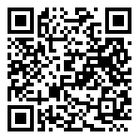
Scan for living source
My Qlink phone still down since early Friday. My zipcode is 16343. Is service down, or something wrong with phone?

Source: https://my.remarkbox.com/8c6b8f75-8f78-11eb-9744-040140774501
Snapshot: 2026-05-03T12:07:37Z
Generator: Remarkbox 763cacb

