Thread 8ceb008d
Source: https://my.remarkbox.com/8ceb008d-e75d-11eb-8a67-040140774501
Snapshot: 2026-05-03T09:25:20Z
Generator: Remarkbox 763cacb
This is a subthread snapshot. The living document lives at the source URI above — it may have been edited, extended, or replied-to since.
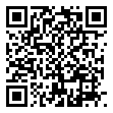
Scan for living source
I've been having the same issues for the last 24+ hours with my phone/service in Chandler, AZ. Any idea of when service in full will be restored?

Source: https://my.remarkbox.com/8ceb008d-e75d-11eb-8a67-040140774501
Snapshot: 2026-05-03T09:25:20Z
Generator: Remarkbox 763cacb

