Thread 8d8d2401
Source: https://my.remarkbox.com/8d8d2401-c964-11eb-a85f-040140774501
Snapshot: 2026-05-03T10:45:49Z
Generator: Remarkbox 763cacb
This is a subthread snapshot. The living document lives at the source URI above — it may have been edited, extended, or replied-to since.
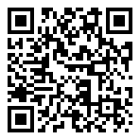
Scan for living source
In idaho. Have been having issues with contacting them since 8:00 a.m. no customer service line or ability to look it up online? This is really bizarre and all I'm trying to do is update my address so I can get the phone that I was supposed to two months ago.

Source: https://my.remarkbox.com/8d8d2401-c964-11eb-a85f-040140774501
Snapshot: 2026-05-03T10:45:49Z
Generator: Remarkbox 763cacb

