Thread 91e65a17
Source: https://my.remarkbox.com/91e65a17-d6ac-11ec-a5f8-b1c8c4ae987e
Snapshot: 2026-04-27T22:31:32Z
Generator: Remarkbox 763cacb
This is a subthread snapshot. The living document lives at the source URI above — it may have been edited, extended, or replied-to since.
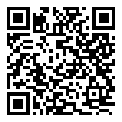
Scan for living source
I have no cell phone service. Says to use Wi-Fi calling, I need to use my phone away from home.

Source: https://my.remarkbox.com/91e65a17-d6ac-11ec-a5f8-b1c8c4ae987e
Snapshot: 2026-04-27T22:31:32Z
Generator: Remarkbox 763cacb

