Thread 931035a3
Source: https://my.remarkbox.com/931035a3-988b-11eb-9904-040140774501
Snapshot: 2026-05-03T12:00:11Z
Generator: Remarkbox 763cacb
This is a subthread snapshot. The living document lives at the source URI above — it may have been edited, extended, or replied-to since.
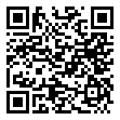
Scan for living source
my phone is a samsung galaxy and since upgrade with qlink my phone will not work my area code 71291

Source: https://my.remarkbox.com/931035a3-988b-11eb-9904-040140774501
Snapshot: 2026-05-03T12:00:11Z
Generator: Remarkbox 763cacb

