Thread 9a7b624b
Source: https://my.remarkbox.com/9a7b624b-e77b-11ec-b9e5-83aad5f5c937
Snapshot: 2026-05-01T19:04:04Z
Generator: Remarkbox 763cacb
This is a subthread snapshot. The living document lives at the source URI above — it may have been edited, extended, or replied-to since.
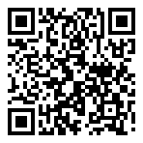
Scan for living source
Surfshark is down for my mobile phone if I log out and try to login again. The app in Linux works fine and can login to the web site. I am in Stockholm Sweden. Looking at the outage map seems like there are lots of problems in europe and USA.

Source: https://my.remarkbox.com/9a7b624b-e77b-11ec-b9e5-83aad5f5c937
Snapshot: 2026-05-01T19:04:04Z
Generator: Remarkbox 763cacb

