Thread 9c7eb375
Source: https://my.remarkbox.com/9c7eb375-9af7-11ec-a46e-b1c8c4ae987e
Snapshot: 2026-05-03T10:46:50Z
Generator: Remarkbox 763cacb
This is a subthread snapshot. The living document lives at the source URI above — it may have been edited, extended, or replied-to since.
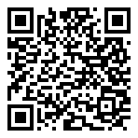
Scan for living source
Unable to make calls using QLink Wireless service. Fortville Indiana

Source: https://my.remarkbox.com/9c7eb375-9af7-11ec-a46e-b1c8c4ae987e
Snapshot: 2026-05-03T10:46:50Z
Generator: Remarkbox 763cacb

